**Satriyo Yudha**

**NIM:233140707111082**

**Modul 4**

**Input Code html**

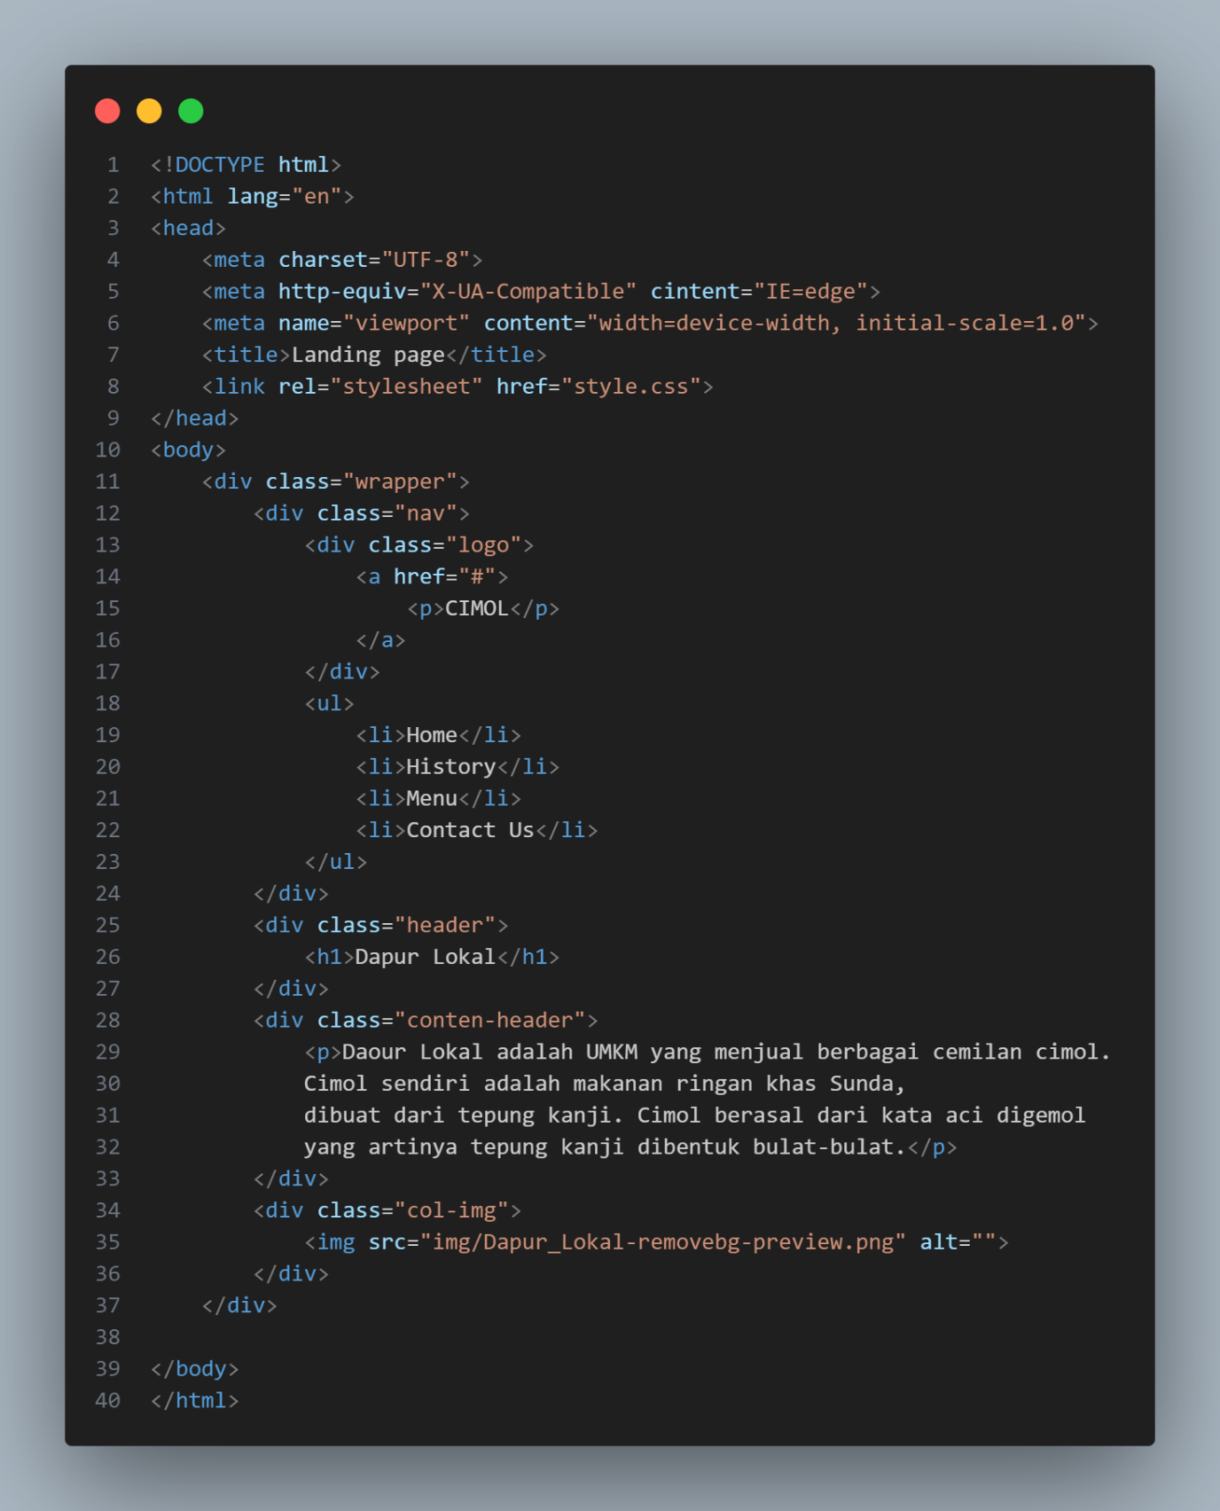

**Input Code Style CSS**

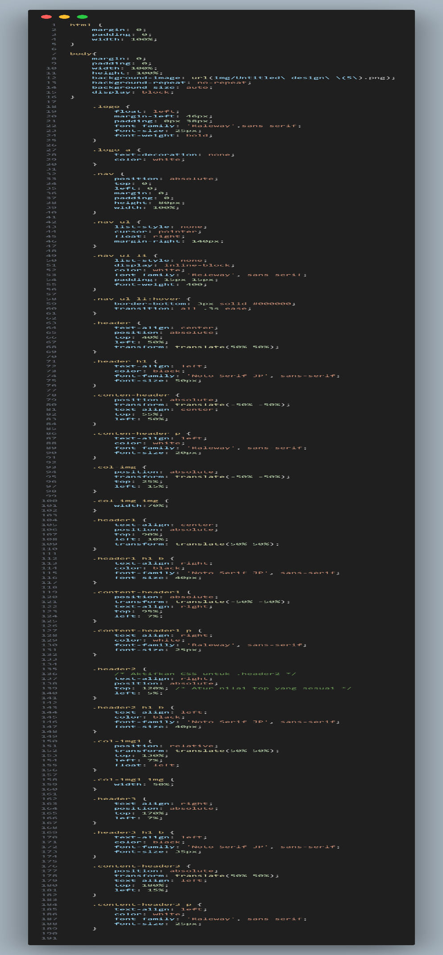

**Output**

